Employee Leave Management App Documentation
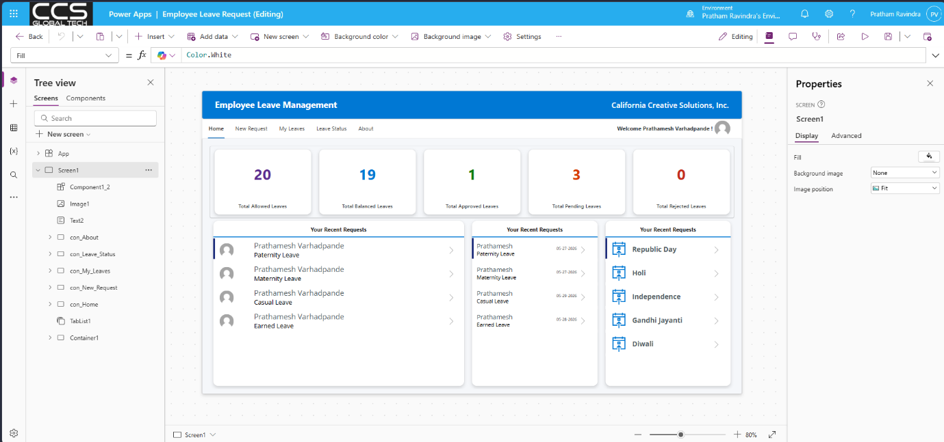
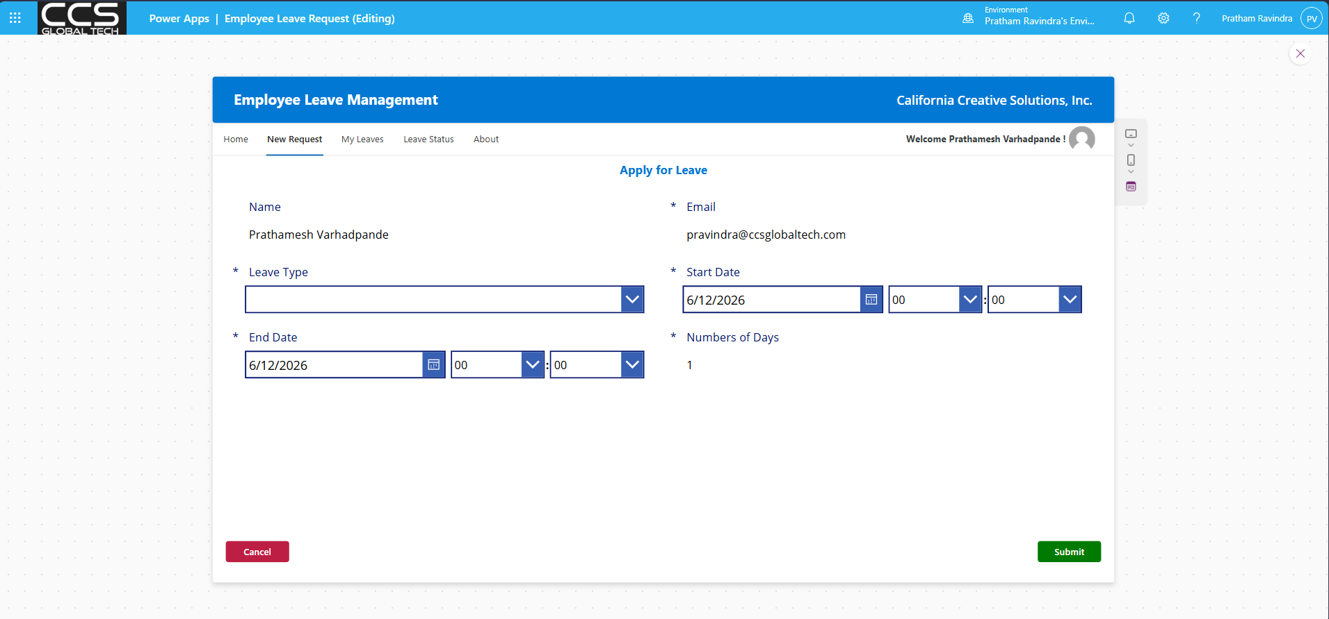
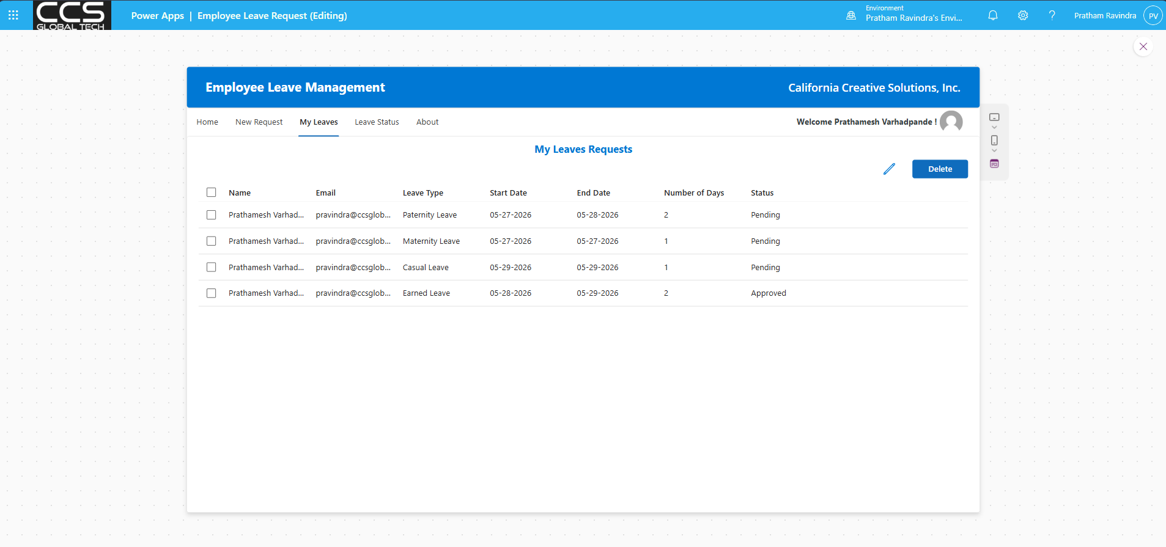
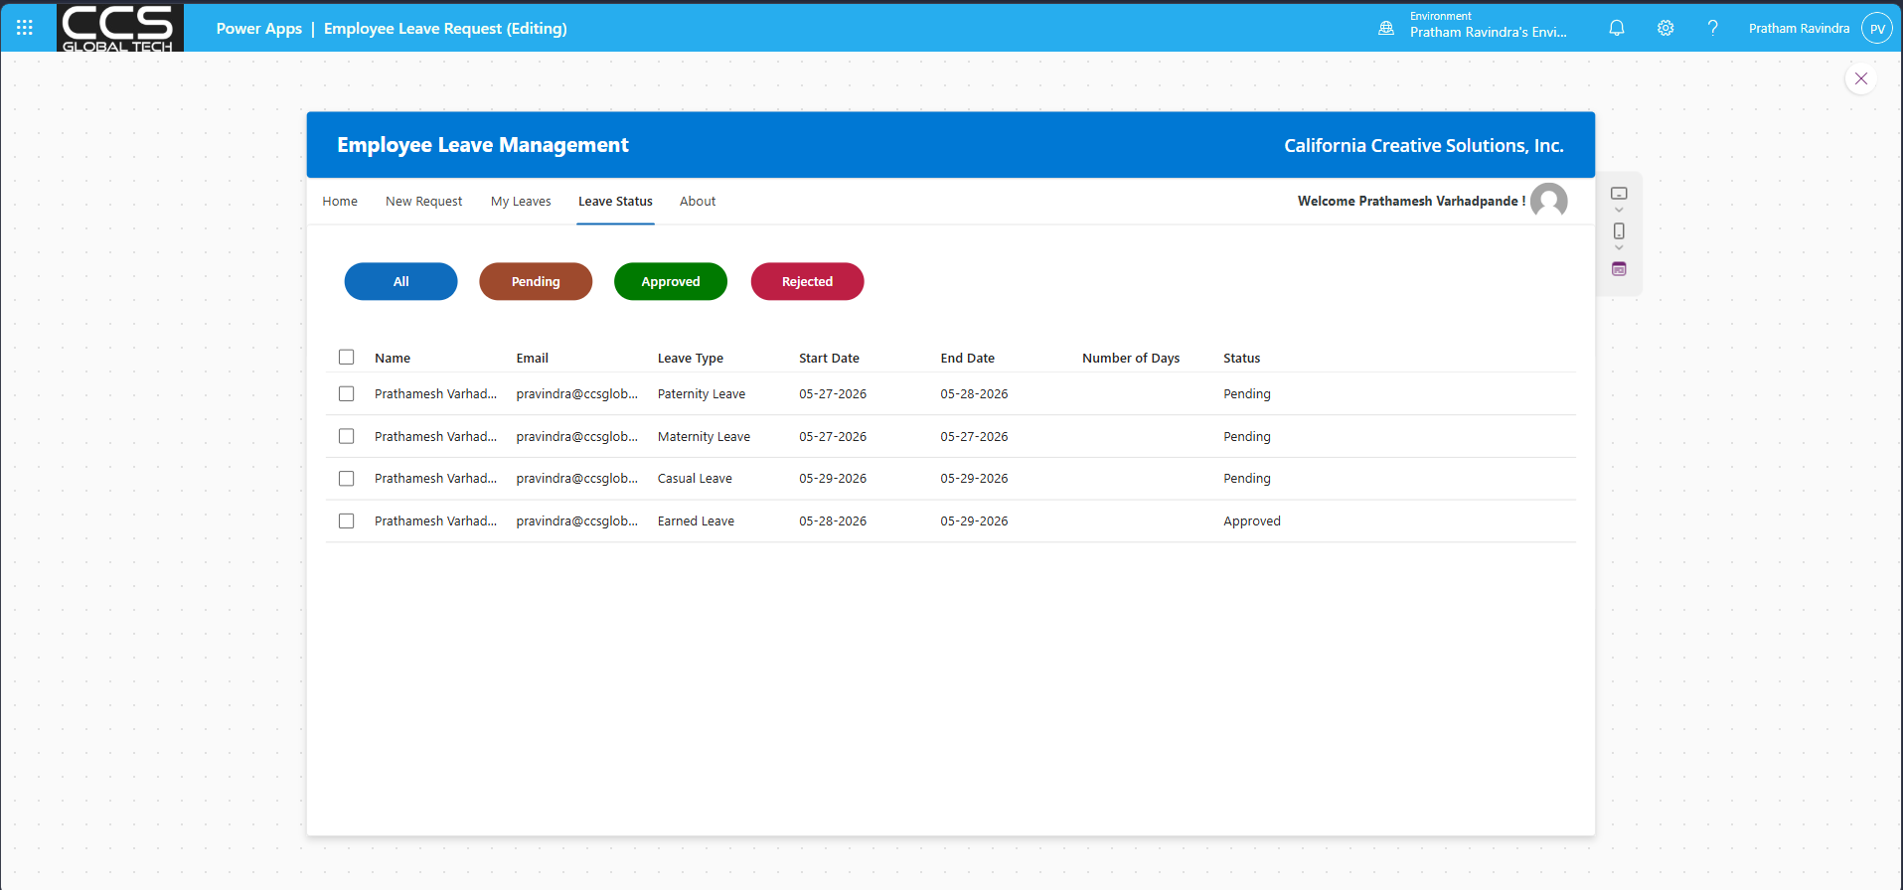
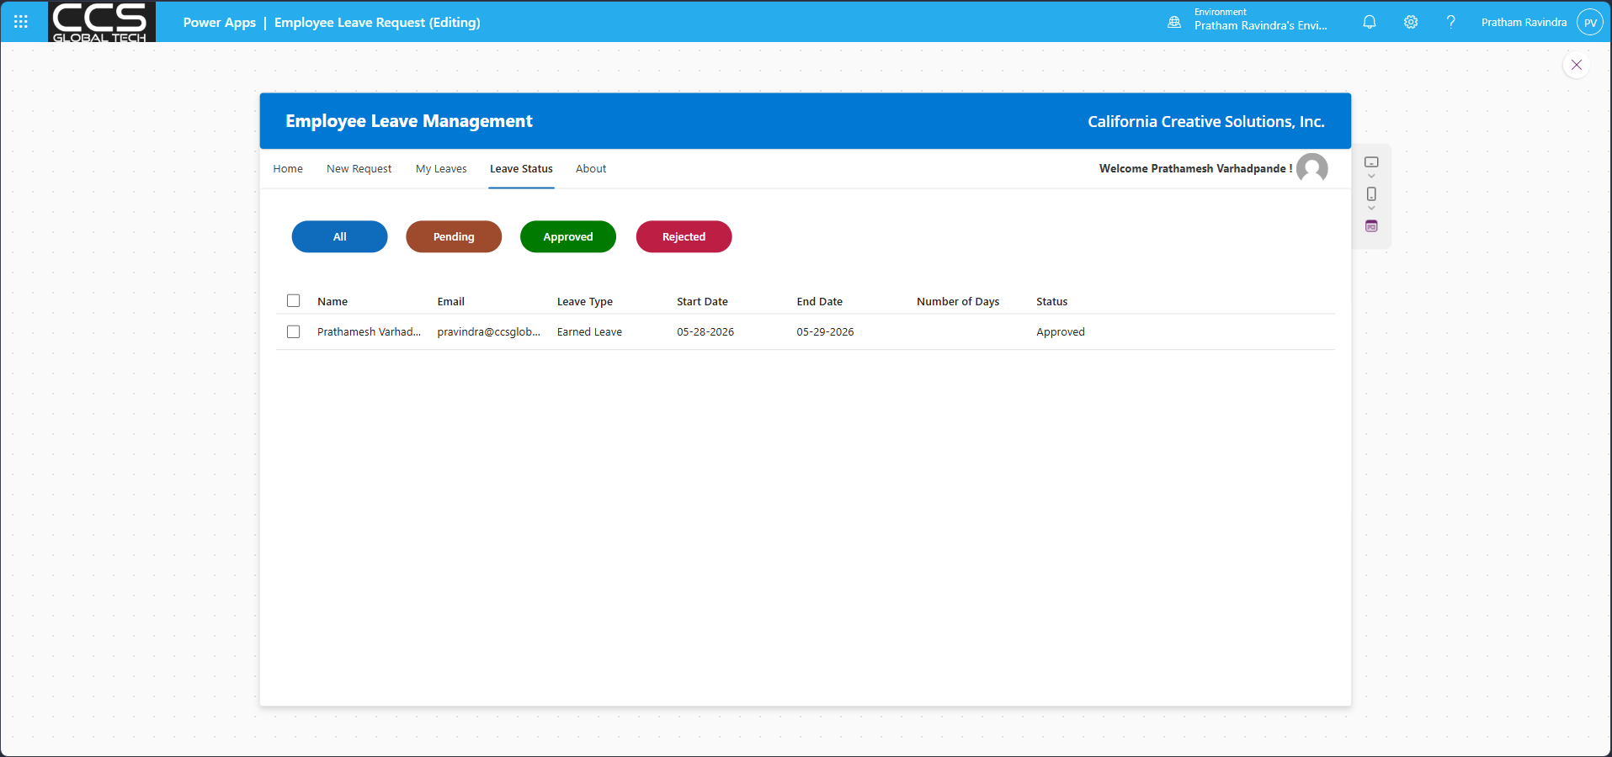
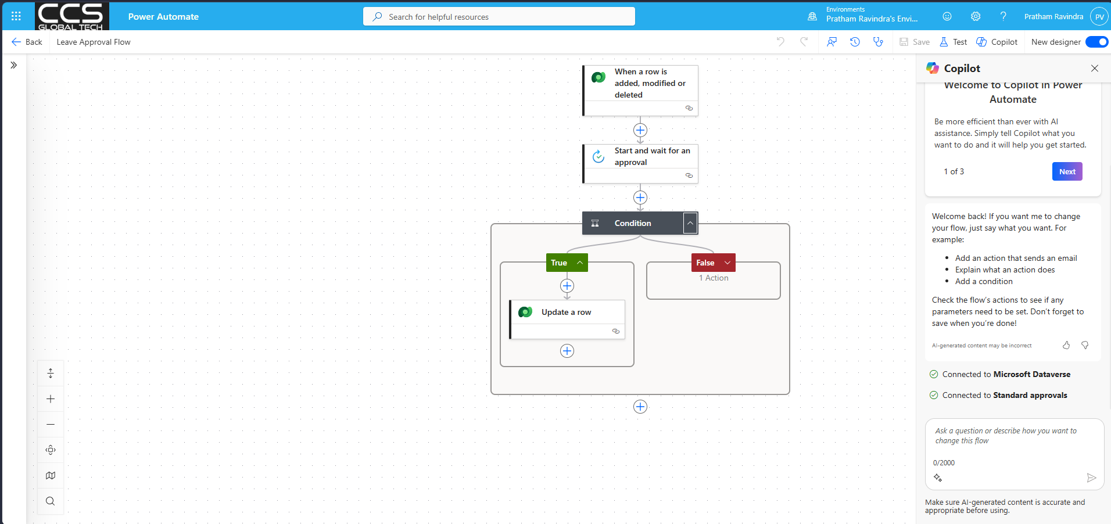

Project Overview
This project is an Employee Leave Management App built in Power Apps using Dataverse as the backend. The app is designed to help employees create, view, update, and delete leave requests in a clean and professional way while following enterprise-style app development practices.
Purpose
The main purpose of the app is to manage employee leave requests in one place. It allows users to submit a new leave request, check their leave history, track request status, and manage pending requests with a simple and organized interface.
Why Dataverse
Dataverse is used instead of SharePoint because it is better suited for enterprise applications. It supports relational data, role-based security, better integration with Power Platform tools, and stronger column types such as choice fields, lookup columns, currency, and attachments.
Data Model
A Dataverse table named Employee Leave Management is created for the app. The table stores key fields such as employee name, employee email, leave type, start date, end date, number of days, status, and manager comments.
The status field uses choice values such as Pending, Approved, and Rejected, with Pending as the default value. This helps standardize the workflow and makes filtering and reporting easier inside the app.
App Structure
The app is created as a Canvas App with a tab-based layout. It includes five main sections: Home, New Request, My Leaves, Leave Status, and About.
Each section is placed inside its own container, and visibility is controlled using the selected tab value. This approach keeps the app organized and makes navigation simple for the user.
Home Page
The Home page works as the dashboard of the app. It shows a welcome message, user photo, and summary cards for total leave allowed, remaining leave, approved leave, pending leave, and rejected leave.
It also includes three additional panels for recent requests, team leave requests, and holidays. These panels help users quickly understand their current leave activity without opening multiple screens.
App Formulas
The app uses App Formulas to define reusable values like current user name, current user email, total leave allowed, and leave summary counts. This makes the formulas easier to manage because the same logic can be written once and reused across the app.
This approach also improves performance because repeated filters on Dataverse can be reduced by storing reusable logic in one place. It makes the app cleaner, faster, and easier to maintain.
New Request Page
The New Request page uses an Edit Form connected directly to the Dataverse table. This form handles both new request creation and existing request editing using the same screen.
Name and email fields are auto-filled using the current logged-in user details and kept read-only. The page also uses the selected record logic so that if a record is chosen for editing, the same form loads that record automatically.
User Defined Function
A user-defined function is created to calculate the number of leave days between the start date and end date. This avoids repeating the same DateDiff logic in multiple places and keeps the app logic more consistent.
The calculated number of days is shown in the form automatically and is also sent to Dataverse during form submission. This ensures the saved value is always correct.
Formula Optimization
The app uses functions like With() and Coalesce() to make formulas shorter and easier to read. With() is used to define temporary values such as whether the form is in edit mode and whether the form is valid before submission.
Coalesce() is used in date fields to return the selected item value if it exists, or today’s date if the value is blank. This makes the edit and new form behavior more reliable with less code.
Form Submission Logic
The Submit button checks whether the form is valid before saving data. If required fields are missing, the app shows an error notification and stops submission.
If the form is valid, the app submits the form, resets it, clears the selected record, shows a success message, and then navigates the user to the My Leaves page. On success and failure, separate notifications are shown to make the result clear to the user.
My Leaves Page
The My Leaves page uses a Data Grid to show the current user’s leave records. This page is focused on viewing and managing records, so a grid is used instead of a gallery for a more structured and professional layout.
The page supports editing and deleting records. Users can edit one selected leave request at a time, and they can delete multiple records only if those requests are still in Pending status.
Leave Status Page
The Leave Status page helps users filter leave requests by All, Pending, Approved, and Rejected. It uses buttons and a data grid to make status tracking clear and fast.
A combination of With() and Switch() is used to match text-based filter values with Dataverse choice values. This makes the filtering logic cleaner and easier to maintain.
About Page
The About page gives simple information about the app such as the app name, version, platform used, and developer details. It acts as a lightweight information screen inside the application.
CRUD Features
The project demonstrates all four CRUD operations clearly. Users can create a leave request, read and filter leave records, update an existing pending request, and delete selected pending requests.
The app also prevents invalid delete behavior by protecting non-pending records. This makes the system more realistic and closer to a real business process.
Design Approach
The app is designed in a clean enterprise style using containers, tab navigation, reusable colors, responsive layout ideas, and clear spacing. It follows a practical development pattern where each feature is added only when needed, which makes the app easier to understand and build step by step.
Outcome
This project is a complete Power Apps employee leave management solution built with Dataverse. It shows how to design a business app with good structure, optimized formulas, reusable logic, and a professional user experience while keeping the implementation simple and practical.

